Press release, 4 November 2005

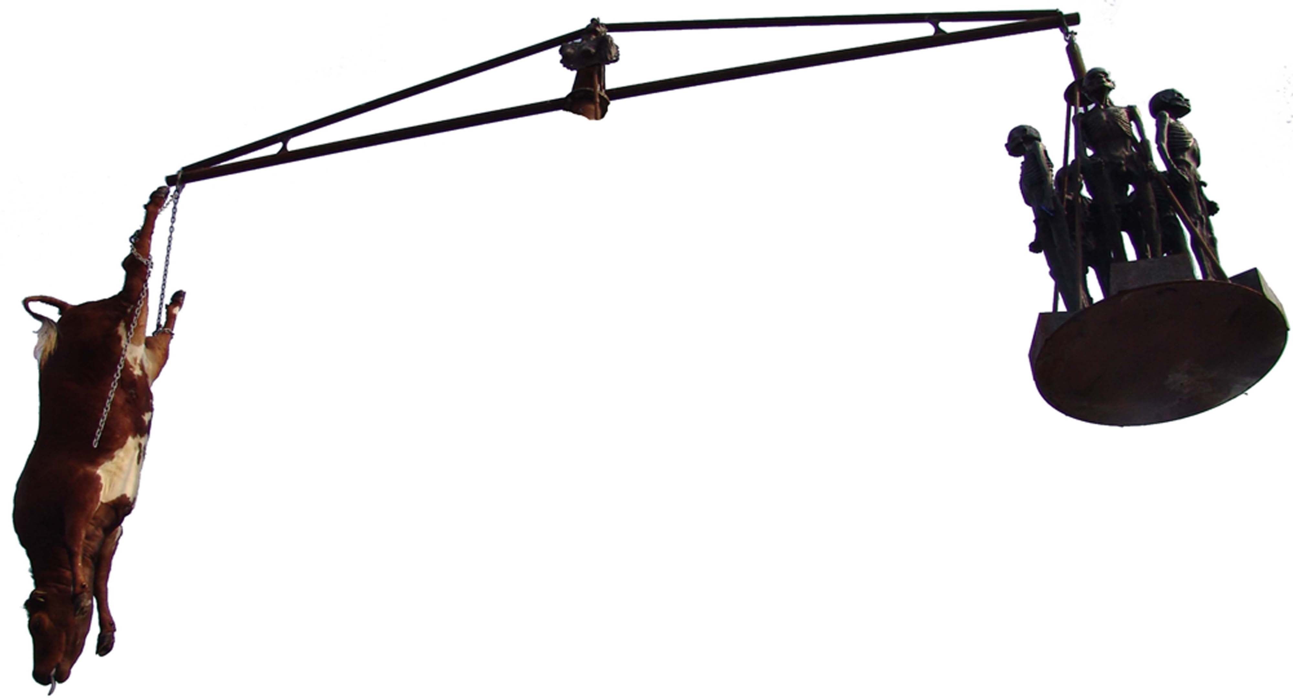
Danish Mad cow Disease heading for Hong Kong

One dead cow - twenty Hunger Boys – a huge scale – an enormous fat woman on the back of a man, on their way in a ship bound for Hong Kong. All of it sculptures created by Danish concept artist Jens Galschiot – except the cow that presumably has been created by artificial insemination.
This peculiar cargo is to join the summit of the World Trade Organisation 13-18 December, where the world’s leaders meet to discuss world trade in the future.
Galschiot will participate with the three sculpture groups expressing his view on world trade. They will be placed in public space in Hong Kong.
Mad cow Disease – a nine metres high pair of scales with a stuffed cow in one arm and five starved African children in the other. A symbol pinpointing that the rich world is using five times the amount of their development aid to support their own agriculture. Each cow in the rich world gets 850 $ in subsidies during its life.
Survival of the Fattest is a three metres high copper sculpture of a fat woman with a pair of scales in her hand sitting on the back of starved African man. The fat woman, Justitia, epitomises the rich world’s self-complacent ‘righteousness’ – and the third world’s view on our conduct.
The Hunger March - twenty copper sculptures of starved children will appear as a mobile manifestation in the many demos expected during the summit.
Galschiot and his sculptures have earlier been involved in turmoil in Hong Kong when he in 1997 set up the eight metres high Pillar of Shame to create a memorial of the crackdown of the student uprising on the Tiananmen square in Beijing in 1989. The Pillar provoked a debate about free speech and in spite of strong opposition from China (and the Hong Kong parliament) it was put up in Victoria Park where 55.000 Chinese participated in a memorial ceremony. Later the Pillar of Shame was placed on the campus of University of Hong Kong, which touched off intense student riots in Hong Kong. The British Governor declared: “There will not be fights about free speech as long as Hong Kong is British territory”. Three weeks later China took over Hong Kong.
The preserved cow of the sculpture Mad cow Disease is declared totally free of diseases and the skin has been tanned professionally. So there is no risk of the veterinary madness. However, you could fear that rich countries will continue their ‘madness of subsidies’ preserving the unbalanced world trade.
Galschiot himself will come to Hong Kong to set up his sculptures and to participate in the discussions. The project is a part of the Danish initiative ‘Stop the Trade Robbery’ of which the NGO Danish Association for international co-operation is one of the prime movers.
Further information and photos available on http://www.aidoh.dk/?categoryID=124

About the Pillar of Shame in Hong Kong: http://www.aidoh.dk/?categoryID=62
Contact the artist: Jens Galschiot, (+45) 6618 4058, aidoh@aidoh.dk, Internet: http://www.aidoh.dk
Danish Association for international co-operation: http://www.ms.dk/sw1577.asp
Nils Broegger Jakobsen, (+45) 6110 0304, nibrja@ruc.dk
Hong Kong People's Alliance on WTO: Mabel Au, (+852) 3173 8412, pawto2005@yahoo.com.hk, http://hkpa.does.it/

