Happening Tuesday 13th Dec. at Victoria Park 1.00 PM as the WTO Ministerial meeting in Hong Kong kicks off
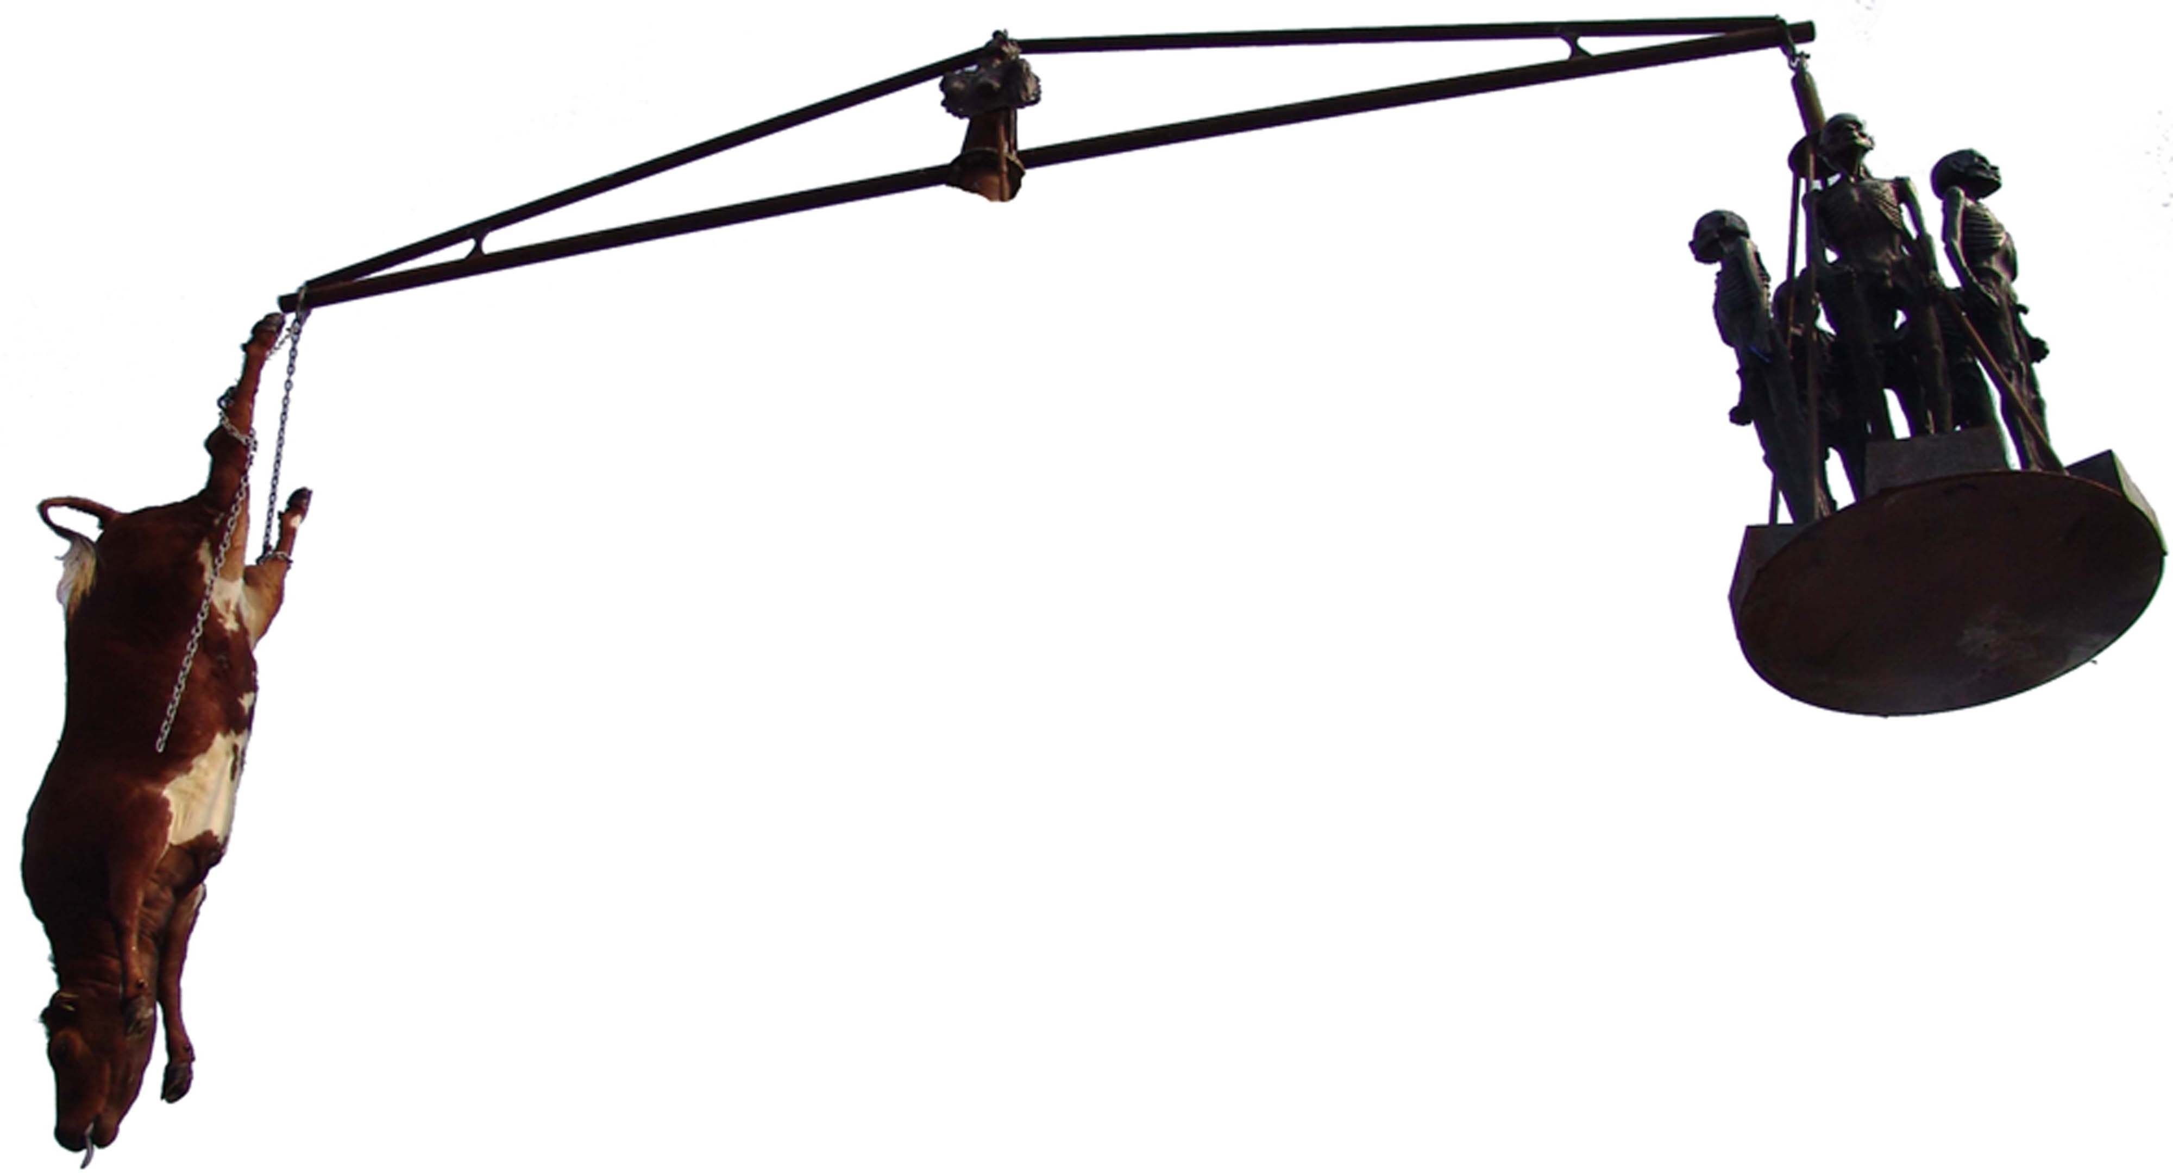

Danish artist Jens Galschiot plants the French flag in the hands of his sculpture Survival of the Fattest to show his dissatisfaction with the protectionist attitude of several EU countries.

Survival of the Fattest is a three metres high copper sculpture of a fat woman with a pair of scales in her hand sitting on the back of starved African man. The fat woman, Justitia, epitomises the rich world’s self-complacent ‘righteousness’ – and the third world’s view on our conduct
“The rich countries continuesly express their will to help the poor people of the world, but keep sustaining a trade regime which makes the lives of poor farmers in developing countries disgraceful and without hope of improvement,” the artist Jens Galschiot says.
“France in particular is obstructing the advancement of progress towards a more fair and just trade system. It does not make sense that a cow in Europe recieves more than two USD in subsidies a day, while 1,2 billion people world wide will have to survive for one dollar only, says MS Vice-chair Nils Broegger Jacobsen.
It’s inhumane that this inverted Robin Hood systeme is continuing and that the willingness for change is surpressed by shortsigthed and narrow minded national economic interests - As the recent budget discussions within the EU have shown. As a human being I have to protest this system,” Jens Galschiot continues.
The sculpture’s presence in Hong Kong is a co-operation between Danish Association for International Co-operation (MS) and Galschiot and is on display in Victoria Park, during the WTO Ministerial meetings. Also on display is Mad cow Disease – a nine metres high pair of scales with a stuffed cow in one arm and five starved African children in the other. A symbol pinpointing that the rich world is using five times the amount of their development aid to support their own agriculture.
Galschiot and his sculptures have earlier been involved in turmoil in Hong Kong when he in 1997 set up the eight metres high Pillar of Shame to create a memorial of the crackdown of the student uprising on the Tiananmen square in Beijing in 1989. The Pillar provoked a debate about free speech and in spite of strong opposition from China (and the Hong Kong parliament) it was put up in Victoria Park where 55.000 Chinese participated in a memorial ceremony. Later the Pillar of Shame was placed on the campus of University of Hong Kong, which touched off intense student riots in Hong Kong. The British Governor declared: “There will not be fights about free speech as long as Hong Kong is British territory”. Three weeks later China took over Hong Kong.

Contacts
The Galschiot group, e-mail aidoh@aidoh.dk, Hong Kong mobile (+852) 9408 6455, mobile through Denmark is (+45) 4044 7058, land line at the workshop in Denmark (+45) 6618 4058. Further info on www.aidoh.dk/WTO

MS group: www.ms.dk/WTO, e-mail nibrja@ruc.dk
Hong Kong mobile (+852) 9506 5373, mobile through Denmark (+45) 3337 4480
Co-operation partner in HK: Hong Kong People’s Alliance on the WTO Summit:
http://hkpa.does.it.it/ Mabel Au, (+852) 3173 8412, pawto2005@yahoo.com.hk

