Useful info for the press and news media, about Galschiot’s participation at the Hong Kong WTO summit 8 - 21 December
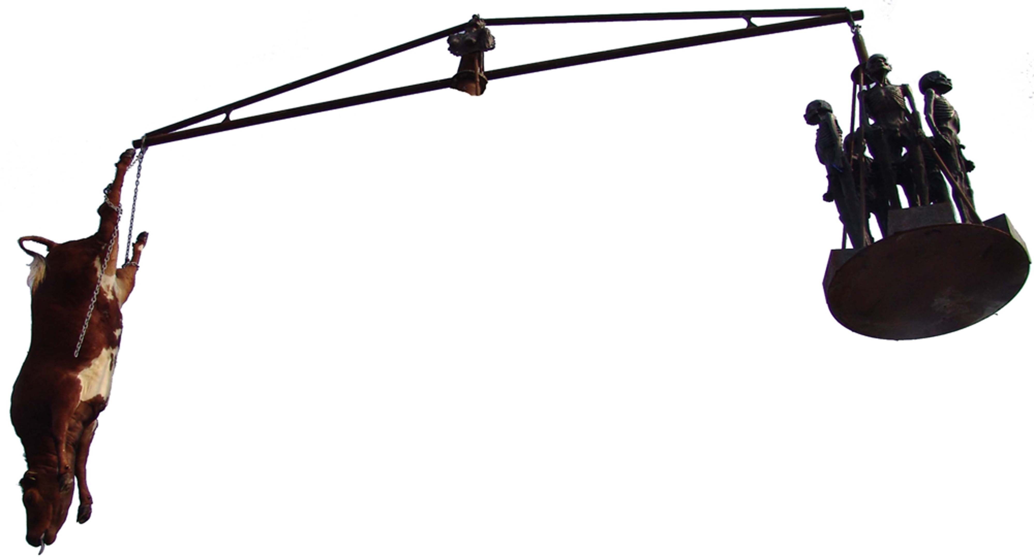
Danish artist Jens Galschiot is going to Hong Kong to erect 3 larger sculpture groups, all illustrating the global inequality. The sculptures will be put up in the public space in Victoria Park in Hong Kong and carried along with the demonstrations. The project is a co-operation between Danish Association for International Cooperation (MS) and Galschiot. Further info on www.aidoh.dk/WTO
MS will send 8 delegates to the WTO summit in Hong Kong on Saturday. While leaving they will make a happening on the town square of Copenhagen disguised as cows. They will drive limos to the airport and go to the meeting to defend their right to get subsidies. Galschiot will leave already on Thursday morning (disguised as an artist). The group contains 4 persons and a TV documentary photographer.
It will be possible to get in contact with us in Hong Kong by e-Mail and phone, we will make a diary, spiced whit a lot of tax free press photos, that will be displayed on www.aidoh.dk/WTO
It will also bee possible to get professional TV footage sent, if an arrangement is made with our photographer Niller Madsen.

Useful info about the Galschiot group in Hong Kong
Participants: Jens Galschiot, Colette Markus, Vagn Frausing, Lasse Markus and our TV Photographer Niller Madsen

Contacts

The Galschiot group, e-mail aidoh@aidoh.dk, Hong Kong mobile (+852) 9408 6455, mobile through Denmark is (+45) 4044 7058, land line at the workshop in Denmark (+45) 6618 4058

TV documentarian Niller Madsen, e-mail: Nillermadsen@hotmail.com, mobile through Denmark (+45) 4021 5415.

Departure from Denmark, Billund, December 8 at 11.20
Arrival in Hong Kong, December 9 at 11.25
Departure from Hong Kong, December 21 at 13.20
Arrival in Denmark: Billund, December 21 at 21.10

MS group: www.ms.dk/WTO, e-mail nibrja@ruc.dk
Hong Kong mobile (+852) 9506 5373, mobile through Denmark (+45) 3337 4480

Both MS and the Galschiot group are staying at: Ah Shan Hostel/ Dragon Inn. Room 406, Sincere house, 83 Argyle street, Mongkok, Kowloon, HK
Phone (+852) 2787 5934, fax (+852) 2787 5495, e-mail 1406@ahshanhostel.com

Co-operation partner in HK: Hong Kong People’s Alliance on the WTO Summit:
http://hkpa.does.it.it/ Mabel Au, (+852) 3173 8412, pawto2005@yahoo.com.hk

Sculptures in Hong Kong will be displayed in Victoria Park Sunday 11 December until Sunday 18 December

Workshop: MS and Galschiot, activities in a tent in Victoria Park at 17 December
in-between 13-18 local time.

When we arrive in Hong Kong we will try to get an overview of the activities that we will participate in and make an activity calendar on the net at: www.aidoh.dk/WTO

The Sculptures, which have just arrived to Hong Kong in a containership:
Mad cow Disease – a nine metres high pair of scales with a stuffed cow in one arm and five starved African children in the other. A symbol pinpointing that the rich world is using five times the amount of their development aid to support their own agriculture. Each cow in the rich world gets 850 $ in subsidies during its life.
Survival of the Fattest is a three metres high copper sculpture of a fat woman with a pair of scales in her hand sitting on the back of starved African man. The fat woman, Justitia, epitomises the rich world’s self-complacent ‘righteousness’ – and the third world’s view on our conduct.
The Hunger March - twenty copper sculptures of starved children will appear as a mobile manifestation in the many demos expected during the summit.

Previous happenings by Galschiot in Hong Kong:
Galschiot and his sculptures have earlier been involved in turmoil in Hong Kong when he in 1997 set up the eight metres high Pillar of Shame to create a memorial of the crackdown of the student uprising on the Tiananmen square in Beijing in 1989. The Pillar provoked a debate about free speech and in spite of strong opposition from China (and the Hong Kong parliament) it was put up in Victoria Park where 55.000 Chinese participated in a memorial ceremony. Later the Pillar of Shame was placed on the campus of University of Hong Kong, which touched off intense student riots in Hong Kong. The British Governor declared: “There will not be fights about free speech as long as Hong Kong is British territory”. Three weeks later China took over Hong Kong.

