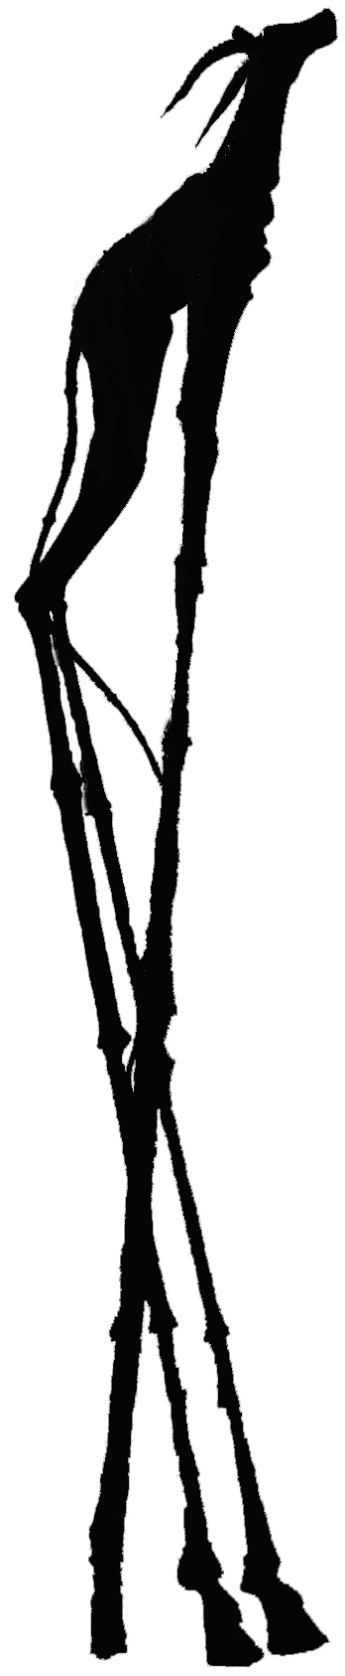
Press release, 18 November 2005

Gold Fever

Raging in Belgium
An eight metres high biblical Golden Calf coated with 24-carat gold foil will take the lead in a procession of artists, the Clown Army, samba dancers and citizens. They will siege the banks in Ghent, Belgium to denounce the unethical investments of the banks.
The two tons heavy Golden Calf, in bronze and pure gold created by the controversial Danish artist Jens Galschiot will join the Gold Fever event organised by Netwerk Vlaanderen on 23 November. The Calf will be carried along the banks on the Kouter sq. and then raised on its six metres high legs. The sculpture will stay on the square until 10 December, International Human Rights Day.
Netwerk Vlaanderen has just launched the report ’Where are the borders’ in which especially the bank groups AXA, DEXIA, FORTIS, ING and KBC are blamed for their cynical investments in arms industry.
Belgian campaigner Mathias Bienstman says: One can see the Golden Calf as a symbol of the idolatry of return and profit. The sculpture will call the banks to account. Why our savings go to weapons, dictators, sweatshops and other unethical investments?
The following groups and collectives will participate in Gold Fever:
- A team of artists with Jens Galschiot (DK)
- Orchestre International du Vetex (BE/FR)
- M.O.M. (BE)
- Sambagroep JNM (BE)
And the Clown Army, Cirque del Mundo and co-workers of Nieuwpoorttheater

More information about Gold Fever: www.mijngeldgoedgeweten.be
Mathias Bienstman, mathias@netwerk-vlaanderen.be
Call from Belgium: 02/2010770 or 0495/832273
Call from abroad: +32 22010770 or +32 495832273
Further information and photos available on http://www.aidoh.dk/?categoryID=136
Contact the artist: Jens Galschiot, (+45) 6618 4058, mobile (+45) 4044 7058
aidoh@aidoh.dk, Internet: http://www.aidoh.dk
Jens Galschiot is available for interviews in Ghent before Gold Fever.

Jens Galschiot (1954), sculptor, stakes his art to defend the ethical values of our society, regardless of political, religious or economic interests. He is internationally known for his art manifestations, especially ‘My Inner Beast’ set up in twenty European cities as a warning against increasing racism and ‘The Pillar of Shame’ erected in Hong Kong, Mexico and Brazil as a remembrance of bloody massacres, see www.aidoh.dk
Netwerk Vlaanderen vzw campaigns for another approach to money. Not the maximum profit but global justice counts. In her new campaign Netwerk Vlaanderen demands the banks to develop a human rights policy on investments. Savings of clients may never go to companies and projects that violate human beings and their rights.
www.mijngeldgoedgeweten.be

