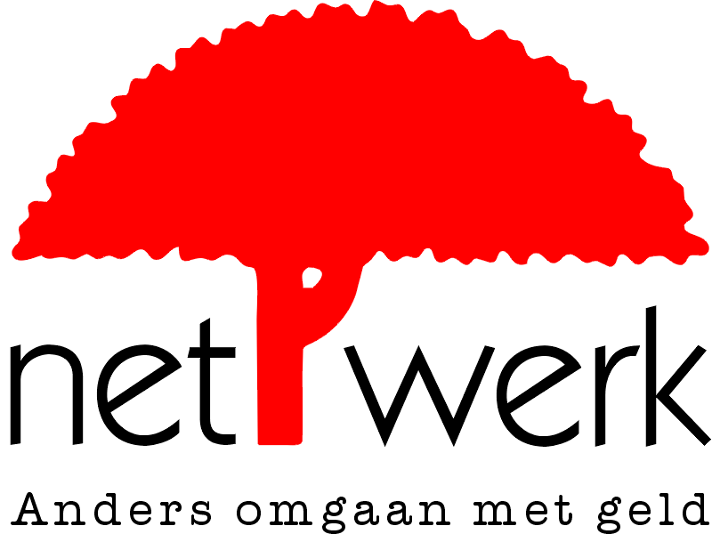

Where are the borders?

A summary of the new report from Netwerk Vlaanderen

Netwerk Vlaanderen, a movement that deals with another approach to money, has been running the campaign “My Money. Clear Conscience?” since 2003. The campaign is designed to force the financial world to take responsibility. Banks work with your money. They invest that money in controversial companies. In this way, your money is invested in weapon producers, companies involved in serious violations of human rights, and environmentally damaging companies. And for one reason or another, the banks would rather not let their customers know about this.

The most recent report of Netwerk Vlaanderen “Where are the borders?” reveals links between five bank groups and companies involved in serious violations of human rights. Research shows that AXA, Dexia, Fortis, ING and KBC have invested more than US$8 billion (more than €6.6 billion) in fourteen such companies. Dexia, Fortis, ING and KBC are also financiers of large-scale infrastructure projects that do not respect human rights.

A number of examples from the report.

Investments in Total, and thus the Burmese military dictatorship
The five researched bank groups invest a total of almost US$2.4 billion in shares in the French company Total.

 | Number of shares | Value of the shares in US dollars | Percentage of the shares in Total
AXA | 4.966.019 | 1.100.671.093 | 0,78%
DEXIA | 1.165.429 | 258.303.089 | 0,18%
FORTIS | 896.414 | 198.679.203 | 0,14%
ING | 2.892.216 | 616.331.230 | 0,46%
KBC | 971.300 | 215.276.769 | 0,15%
Total | 10.891.378 | 2.389.261.384 | 1,72%

Total is the fourth largest oil and gas company in the world. The company is also the largest international investor in Burma.

Burma has been a military dictatorship since the 1960s. The elections held in 1990 were won by the nonviolent democratic opposition, led by San Suu Kyi, Nobel Peace Prize winner in 1991.The military junta refused to transfer power, and ruled over the Asian country with an iron fist. Forced labour, torture, child soldiers, and other human rights abuses are run of the mill occurrences. The Burmese economy is completely in the control of the military regime. The income and profits of Burmese companies are therefore a direct support to the military regime.
For this reason, San Suu Kyi has called on the business world to end all investments in Burma. Many companies have heeded this call. But a number of companies continue to do business with the regime.
In 1992 Total won a contract for the extraction of gas along the Burmese coast. The operation of the Yadana gas field, including the laying of a large pipeline, took place in a direct joint venture with the military regime in Burma. The laying of the pipeline was made possible with the use of Burmese troops, popularly known as “the Total Battalions”. Villages along the route of the pipeline were evicted by the military, and the local population were forced to work for free in the construction of infrastructure for the project. Forced relocations, torture, rape and forced labour became all too common events during the laying of the pipeline.

These abuses of human rights committed by Total have not prevented the above mentioned bank groups from investing heavily in the company. At the beginning of 2005, Fortis also led the share issue of Total Capital on the Benelux capital market (worth €56 million).

Investments in Wal-Mart, three times winner of the award for ‘Sweatshop retailer of the Year’
The five researched bank groups invest a combined total of more than €1.6 billion in Wal-Mart.

 | Number of shares | Value of the shares in US dollars | Percentage of the shares in Wal-Mart
AXA | 18.500.638 | 873.785.133 | 0,44%
DEXIA | 872.740 | 41.206.758 | 0,00%
FORTIS | 564.345 | 26.654.014 | 0,00%
ING | 14.096.764 | 665.790.164 | 0,33%
KBC | 782.203 | 36.943.448 | 0,00%
Total | 34.816.690 | 1.644.380.517 | 0,82%

Wal-Mart is the largest distribution chain in the world, with a turnover of US$285 billion in 2004. The company has 1.6 million employees in 3,600 warehouses, primarily in the United States.

Wal-Mart is not a bad investment for these banks, but there is a bad smell hanging around the company. The US distribution chain is widely known for its obstinate breaches of basic workers' rights. The pitiful working conditions within the company and its suppliers have led to the company being awarded the 2005 Public Eye Award for the most irresponsible company in the field of workers' rights. Wal-Mart has already won the unenviable award of ‘Sweatshop retailer of the Year’ three times. The prize is awarded by the Maquila Solidarity Network.
The fact that Wal-Mart often takes its place on the winners’ rostrum is not really surprising. A review of the practices makes a lot of things clear.
In the United States, Wal-Mart has been condemned for breaching the child labour laws in its warehouses. In the United States there are still dozens of cases pending against the company for 'union-busting'. The management registers, threatens and illegally fires trade union activists. Trade unions are not welcomed by Wal-Mart, and Wal-Mart has already been found guilty of ‘union busting’ on a number of occasions. Poor conditions are also routine in the subcontractors of Wal-Mart, which advertises itself using the slogan ‘Always Low Prices’. At one subcontractor in Kenya, workers were fired after a one-day strike. The strike was a protest against sexual intimidation, non-payment, repression of trade unions, and unpaid overtime. Similar conditions have been found in subcontractors in El Salvador, Lesotho, Indonesia, Bangladesh, China, Nicaragua and Swaziland. People are working in pitiful conditions, so that Wal-Mart can fill its shelves with the lowest priced products.

Lucy's story
Lucy, a Kenyan mother of two, works in a free trade zone sewing the pockets onto children's jeans destined to be sold at Wal-Mart. She says "A year ago, I worked 48 hours non-stop to meet the shipping deadline set by our boss. My husband walked out, making it difficult for me to pay the rent for my apartment, and my children had to go and live with my parents. I have not seen them for six months. If this EPZ could be better, and give us leave and holidays, then I would be able to go and see the children (...) Supervisors abuse us, and if we talk they say, "shut your beak, even a child can do your job". As women we feel so oppressed. Because you can't secure your job through the trade union, you have to buy it with sex.“

Wal-Mart doesn't seem to take much notice of these criticisms. The company has taken hardly any action to improve these terrible working conditions. Wal-Mart continues to be far behind other companies in this respect.

However, the five researched banks believe that investing in Wal-Mart is perfectly reasonable.

Investments in the BTC pipeline
Fifteen international banks are contributing to the financing of the large BTC pipeline. KBC, Dexia and ING are among these banks.

The Baku-Tbilisi-Ceyhan oil pipeline is the largest and most complex transnational infrastructure project in the world. The total investment in the project is US$20 billion. The 1,700 km long pipeline has been designed to carry crude oil, extracted in the Caspian Sea, to the Mediterranean Sea. The route crosses Azerbaijan, Georgia and Turkey, and ends at the Turkish harbour of Ceyhan. From here, the oil can be taken around the world by ship. The first oil was pumped in May 2005. The completion of the project is expected in December 2005.

However, as plans for the pipeline progressed, it became clear that the project would support undemocratic regimes, exacerbate regional conflicts, lead to the violation of human rights, and cause environmental damage.
International observers repeated warned that people living along the route of the pipeline would not be compensated fully, or at all, for the land that they lost. In many cases these are vulnerable communities, for whom the loss of springs, pasture or agricultural land could have disastrous consequences. These communities were forced to relocate, and were left to fend for themselves.
Many communities protested against these practices, but the protests were heavily repressed in all three countries. The consultation with the effected communities left a lot to be desired. Those making their criticisms of the pipeline public were often the target of serious repression, arrest and intimidation by the authorities. This is not surprising given the human rights situation in each of the countries.
Azerbaijan is led by an authoritarian regime led by the Aliyev family. Georgia is plagued by corruption and armed conflict. Human Rights Watch has reported torture in prison, which the government does not take steps to prevent. In Turkey, the Turkish Gendarmerie is responsible for the security of the pipeline. This Gendarmerie has a very dubious human rights record. Furthermore, there has been a far-reaching militarisation of the complete route of the pipeline.

Despite these problems, banks including KBC, ING and Dexia see no problem in financing the BTC project. Multiple protests against their involvement in the BTC project have been ignored.

No concern for human rights
The examples given above are just a few of practices revealed in the Netwerk Vlaanderen report ‘Where are the borders?’ However, even the complete report shows only the tip of the iceberg.

The report allows the following conclusion to be made: the researched banks have no problem at all with investing in companies that are involved in serious breaches of human rights. That is naturally not comforting. Certainly not if you realise that these investments are made with the money of bank customers, and therefore money from all of us.
Forced labour, intimidation of trade union members, support for dictatorial regimes, forced relocation, seem to be perfectly acceptable to some companies. The bank groups see no reason to cut off the supply of money to these companies.

AXA, Dexia, Fortis, ING and KBC have made little or no attempt to avoid investing in serious abuses of human rights.

Another route is needed
Netwerk Vlaanderen wants to call a halt to such an unscrupulous investment policy.
The campaign “My Money. Clear Conscience?” informs bank customers about the unacceptable investments of their bank. Customers can go directly to the banks with these demands.

The campaign demands towards the bank groups are:

Stop investments in serious human rights abuses
Netwerk Vlaanderen asks that the bank groups investigate and put an end to their investments in companies that are accused of serious breaches of human rights.

Clear and controllable investment policy
Netwerk Vlaanderen asks that the bank groups make known, and implement, a clear policy regarding human rights, and that they also make known which companies and governments they are investing in.
The client has a right to know what is happening with money invested or saved with the banks, and needs this information to make an informed choice. Society also has a right to this information. Only if it is to judge whether the bank group is actively supporting or hindering the implementation of the Universal Declaration of Human Rights.

The government also has a role to play on this issue. It is governments, including the Belgian government, that have signed the Universal Declaration of Human Rights. They have to make sure that they respect the declaration themselves, and also have a duty to ensure that businesses operating in their territory also respect human rights.
The government should therefore set a good example. It is unacceptable that government should invest resources in companies that seriously damage human rights. All levels of governments must also develop a responsible saving and investment policy.

The government must also ensure that the bank groups respect human rights. For this reason, legislation must be drawn up at national and international level to oblige banks to be open and responsible about their dealings with human rights.
The government must also support the development of an international framework for business on the issue of human rights. This could be through the implementation, further development, and promotion of the UN Norms for Business.

November 2005

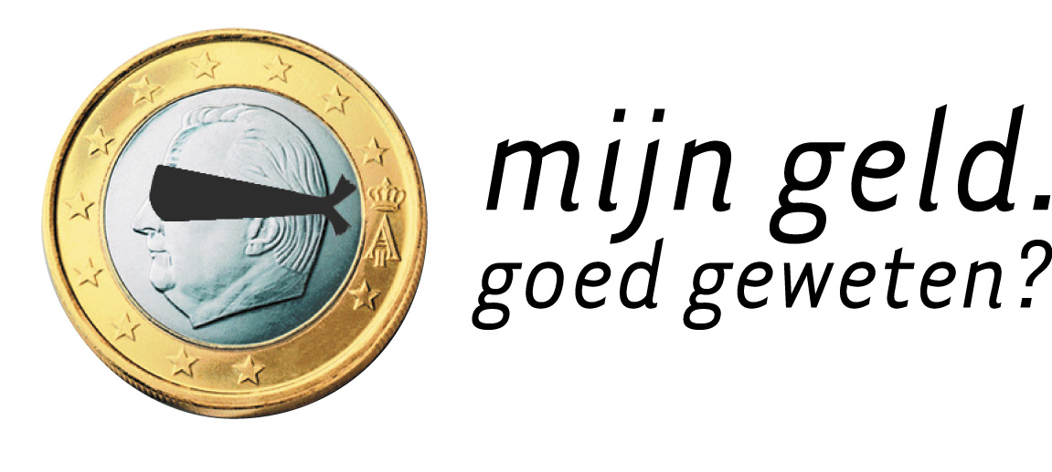

The complete dossier is available to download at www.mijngeldgoedgeweten.be
Press spokesperson: Inez Louwagie; Mobile: +32 (0)498 682940 e-mail: inez.louwagie@netwerk-vlaanderen.be

Netwerk Vlaanderen vzw promotes an alternative approach to money. Money is an instrument that – if applied well – can promote a sustainable and honest society. For the past few years, Netwerk Vlaanderen has been running the campaign “My Money. Clear Conscience?” to make the investment policies of the banks public, and enforce the participation of the saver and investor in the destination of their money. Netwerk Vlaanderen provides information on sustainable investment and savings products, and supports and advises organizations and companies who (wish to) have a socially and environmentally friendly approach to money.

Netwerk Vlaanderen vzw – Vooruitgangstraat 333b9 – 1030 Brussels – 0032 (0)2/201.07.70 – www.netwerkvlaanderen.be
Netwerk Vlaanderen is a member of BankTrack, an international movement for sustainability in the financial sector. www.banktrack.org

Netwerk Vlaanderen and her partner organisations want to use the campaign ‘My Money. Clear Conscience?” to show the financial world where its responsibilities are.
Banks work with your money. They invest that money in various companies, including those responsible for weapon production or human rights abuses. We demand that the banks are open about which companies they finance. And we demand that they end their investments in companies involved in the production of weapons and the abuse of human rights!

Other publications by Netwerk Vlaanderen in the campaign ‘My Money. Clear Conscience?’

My Money. Clear Conscience? – research into the financial links between banks and weapon producers, Christophe Scheire, October 2003 (Dutch only)

Cluster Bombs, Landmines, Nuclear Weapons and Depleted Uranium Weapons. A report on the financial links between banks and the producers of controversial weapon systems, Christophe Scheire, April 2004

Banks Disarm(ed). An Overview of the results of the campaign 'My Money. Clear Conscience?', April 2005

Statement taken and summarised from Aisha Bahadur, “Wal-Mart: Menace to social and labour standards worldwide” www.evb.ch

