Press release November 26 2009
Fat lady fished up from Øresund
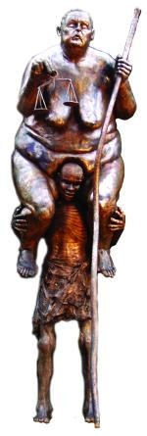
With a heavy lorry of 22 tons and a 27 metres crane as ’fishing rod’, Galschiot’s sculpture ‘Survival of the Fattest’ was fished up from Øresund. The 3 metres high sculpture was set up last week in the water next to The little Mermaid, but during Wednesday night the sculpture suddenly disappeared.
“The sculpture has probably been overturned by a boat or the like, but it is hard to say. The sculpture could also have been working its way down into the sand and then turned over to the side. I was there this morning with a crane and one of my employees. We were quite excited to see if there was a sculpture under the water at all, or someone had stolen the 800 kilo sculpture. Or maybe someone had cut off the head of the fat lady, like we have heard they are in the habit of doing in Copenhagen,” says Jens Galschiot and continues:
”Luckily we found the sculpture under the water, and with struggle we got it back on land. It was a humorous sight to see the fat lady appear turned upside down and fortunately it was intact, even though she was daubed with water and mud.
Now we have stabilized the sculpture with some great iron bars, which made it much harder to overturn. We hope that it will keep standing until the conference is over, so the delegated will see both the mermaid and the fat lady, which are a comment about the Third World being the one to carry the biggest human costs of the global warming,” concludes Galschiot.
Photos (free) of the fat lady being fished up.
Courtesy www.SevenMeters.net
www.SevenMeters.net/bigerection
Videos (free) from the re-erection today November 26:
www.aidoh.dk/Up-again
Contact Jens Galschiot, phone 6618 4058, mobile 4044 7058
Mail: aidoh@aidoh.dk, info: www.aidoh.dk

More information: info: SevenMeters.net
Photo: http://SevenMeters.net/links/6/ tel. 6170 3083 / 6618 4058

Professional documentary shoots of the Mermaid set up:
Niels Madsen, mobile: 40 215 415, nillermadsen@mail.tele.dk, www.osrtv.dk

