Press release, 25 May 2007

Nicaraguan women die in the name of God
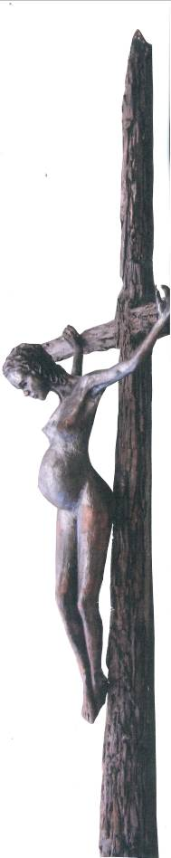
Danish artist Jens Galschiot’s provocative sculpture ‘In The Name of God’ is the cornerstone in a campaign launched by Nicaraguan women’s groups to fight maternal mortality. 37 pregnant women have died during the first 3 months of 2007 because they were denied abortion although the delivery turned out to be life threatening. The dead mothers leave 80 children.
Jens Galschiot launched his sculpture of a pregnant crucified teenager in December 2006 as an outcry against the crusade against contraception and sexual education orchestrated by Christian fundamentalists with president Bush and the pope in the lead.
Now the artist has sent his sculpture to Nicaragua to join a mobilisation of women’s groups saying no to the ‘silent epidemic’. Supported by doctors, human rights groups and universities they mobilise in May to fight against maternal mortality. They fight for the many pregnant women, who die because of carelessness, bad medical care – and because of the country’s total ban against abortion. 49 pregnant women’s lives are every day endangered in Nicaragua, due to the anti-abortion law that threats doctors with 8 years in jail, if they – to rescue the mother, hurt the embryo.
The 5 metre high cross with the pregnant teenager started its tour around the country on 20 May as an eye-catcher of the campaign. To boost the impact, the women have produced hundreds of small copies of the sculpture to be handed out to parliamentarians, the judiciary and other authorities.
Magaly Quintena, an activist from ‘Catholic Women for the Right to Choose’ is enthusiastic about the many-sided symbolism of the sculpture. “One point”, she says, “is that the teenager reminds us of the vision of God as a woman, an aspect that is generally neglected. Our vision of God is dominated by the male image. Another point is that she reminds us of the tragedy that pregnant women experience in the poor countries.”
The campaign was launched on 17 May with a press conference and a blockade in front of the Supreme Court and at the motorway. The Pregnant Teenager started its tour in the provincial town of Estelí. Next step will be the country’s next largest city, León where it will be exhibited in front of the cathedral. On 28 May, the UN day against maternal mortality, the sculpture will join a big rally in the capital.
The campaign against maternal mortality is not only a showdown with the country’s mighty Catholic Church and a huge gathering of protestant denominations. It can also reckon with fierce resistance from practically the whole political spectrum. Only the small Reform Sandinist Party is supportive of ranking the mother’s life at least as high as the embryo’s.
At the other end of the world, in London, another specimen of Jens Galschiot’s Teenager has been banned from the Your Voice Against Poverty rally on 2nd June, because the English grassroots are afraid of offending Christian fundamentalists. It seems that the struggle for women’s rights is not so essential for the British feminists that they will risk a confrontation with fundamentalist circles.
For more information: http://www.aidoh.dk/Nicaragua
Photos from the Nicaragua campaign: http://www.flickr.com/photos/22898994@N00/tags/abortoterapeutico
About the exhibition in London: http://www.aidoh.dk/London
More info about the sculpture: http://www.aidoh.dk/InTheNameOfGod

Plenty of photos of the sculpture: http://www.aidoh.dk/?categoryID=215
Contact the artist: Jens Galschiot – Banevaenget 22 – DK-5270 Odense N
Tel. +45 6618 4058 - Fax +45 6618 4158
E-mail: aidoh@aidoh.dk - Internet: www.aidoh.dk

