Press release, 29 May 2007
Your Voice Against Poverty bans sculpture
The artist: the sculpture is free for another exhibition – if anybody has the guts
The African women's NGO Rainbo has been forbidden to exhibit a controversial sculpture at the Your Voice Against Poverty rally at the brink of the Thames in London on 2nd June. The Danish artist Jens Galschiot is astonished. He declares: I have been censored by totalitarian regimes, but I have never imagined my sculptures to be banned by 'progressive' Western NGOs.
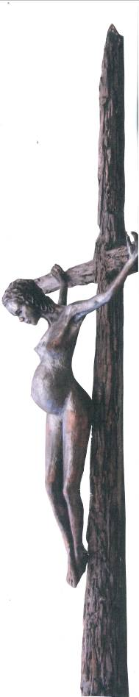
The ban has been decreed by BOND, the organizer of the event, allegedly motivated by a wish to please the affiliated Christian organisations. The banned piece of art is a handsome bronze sculpture depicting a crucified pregnant teenager, created by Danish sculptor Jens Galschiot. The sculpture titled In the Name of God has been cast in various varieties as an accusation against the crusade against contraception and sexual education orchestrated by Christian fundamentalists with President Bush and the Pope in the lead.
The sculpture was scheduled to arrive in London on Thursday carried by a volunteer from the artist’s workshop. But now the artist has been left over with tickets already booked and paid and an unwanted sculpture. Therefore I’ll lend the sculpture for an exhibition to other organisations, art galleries or museums in London, if anybody has the guts – otherwise I’ll have to cancel the journey, the Danish artist says. Jens Galschiot can be contacted at aidoh@aidoh.dk.
The sculpture has been exhibited at WSF2007 in Nairobi, Kenya and for a couple of months in front of the Lutheran Cathedral of Copenhagen in co-operation with the dean and the parish council who wanted to make a statement that not all Christian circles are supportive of the crusade of the Pope and the fundamentalists.
For the moment feminists in Nicaragua are using a specimen of the Pregnant Teenager for a comprehensive campaign against the alarming maternal mortality. In addition they have made hundreds of miniature models of the sculpture to be distributed to parliamentarians, members of the Judiciary and other outstanding persons.
On 22 May the African women’s NGO Rainbo and Jens Galschiot have separately sent a protest to all member organisations of BOND. The Danish sculptor declares:
For decades I've been staking my sculptures to ignite a debate about the North/South relation - and the inequitable distribution of the world's resources. My huge sculptural manifestations have been a well-known and appreciated component of international NGO rallies such as the European Social Forums in London, Paris and Athens, the WTO Ministerial Conference in Hong Kong 2005, Jubilee 2000 in Prague - just to mention a few examples.
For sure, I have been censored by totalitarian regimes, e.g. the Chinese government, and I have been expelled from Mexico for the 'crime' of erecting a 'Pillar of Shame' against the Acteal massacre in co-operation with the CNI, the indigenous peoples' organisation. But I have NEVER had an experience like this: that 'progressive' NGOs like BOND or other democratic western NGOs make an attempt to obstruct the exhibition of one of my sculptures. Indeed, such 'progressive' grassroots' circles, are the last ones that I would deem to be supportive of the crusade against contraception and sexual education orchestrated by the Pope and President Bush.
As no argument has induced the organisers to change their absurd decision, Jens Galschiot has now decided to publish the affair.
For more information:
Jens Galschiot’s address to the NGO’s: http://www.aidoh.dk/BOND
Rainbo’s address to the NGO’s: http://www.aidoh.dk/Rainbo-letter
Free photos of the sculpture: http://www.aidoh.dk/?categoryID=215
More information about the planned exhibition in London:
http://www.aidoh.dk/London
Contact to the artist: Tel.: +45 6618 4058
E-mail: aidoh@aidoh.dk - Internet: www.aidoh.dk
Responsible for the decision, Tom Allen can be contacted at tallen@bond.org.uk , +44 (0)20 7520 0253

