Press release, 14 February 2007

The Women's Museum in Denmark Grants Asylum to Pregnant Teenager
The Women's Museum in Denmark harbours Danish sculptor Jens Galschiot’s artwork ‘In the Name of God’. The 7 metre high sculpture depicts a crucified pregnant teenager. The crucifix was put up on Wednesday 14 February at the Women’s Museum, neighbouring the Cathedral of Aarhus.
At the inauguration there were speeches by Mr Bjarne Oerum, chairman of the parish council, curator of the museum Ms Merete Ipsen and the sculptor Jens Galschiot. Mr Oerum stressed the role of art for the renewal of the churches. Ms Ipsen emphasized the role of Mathilde Fibiger, born 1830, who had given name to the square of the exhibition. She was a pioneer for the Danish women’s emancipation. Ms Ipsen stressed the affinity between the pioneers and the cause of the sculpture.

From cathedral to cathedral
The controversial sculpture has been exhibited for a couple of months in front of the Cathedral of Copenhagen, where it was put up in co-operation with the Dean and Parish Council. The exhibition in Aarhus has also a connection to the Cathedral, although the sculpture is displayed under the auspices of the Women’s Museum.
Jens Galschiot’s new art manifestation In the Name of God is launched to highlight Christian fundamentalists’ attempt to the world’s policy on contraception, alleging that the use of condoms is a kind of abortion and therefore contrary to God’s will. About this policy the artist declares: The consequences for the proliferation of AIDS are disastrous and the advances of the women’s movement are being set back to the Victorian era.”

From woman to woman
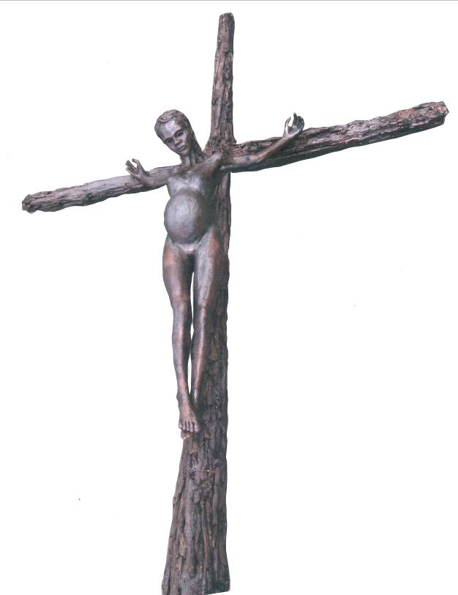
The artist has recently been to Nairobi where he displayed his crucifixion sculpture. The reactions of the 66,000 participants of the World Social Forum were generally benevolent. Especially the women in the demonstrations in the streets of Nairobi and at the venue of the WSF adopted the sculpture and saw it as a symbol of the oppression women that usually follows in the wake of the fundamentalists’ campaign, Jens Galschiot declares and continues: So I’m delighted that exactly the Women’s Museum is the driving force for launching the sculpture here in Aarhus.
For more info and photos of the event, see
www.aidoh.dk/Aarhus
The artist: Jens Galschiot
Banevaenget 22 - DK-5270 Odense N
Tel.: +45 6618 4058 – Fax: +45 6618 4158
E-mail: aidoh@aidoh.dk - Internet: www.aidoh.dk
The Women's Museum in Denmark
Curator Ms Merete Ipsen
Domkirkepladsen 5 – DK-8000 Aarhus C - Tel.: +45 86 1864 84
E-mail: mi@womensmuseum.dk
Internet: www.womensmuseum.dk
Chairman of the parish council – Mr Bjarne Oerum
Skt. Olufs Gade 1, 1. – DK-8000 Aarhus C - Tel.: +45 8612 5497

