Press release 28 April 2006 Page 1 of 2

Sculptural outcry in Athens
Danish sculptor Jens Galschiot launches a sculptural manifestation during the European Social Forum in Athens 4 - 7 May. The three metre high copper sculpture Survival of the Fattest has been mounted on a truck pulling 6 trolleys with 12 copper sculptures of emaciated teenage boys. The sculptures were last displayed in Hong Kong where they fanned the discussion about the WTO summit. The grotesque sculpture procession will take part in many of the meetings and the huge demonstration where hundreds of thousands are expected to participate. The Social Forum in Athens is a follow-up of the big gathering in Porto Alegre, Brazil. The European grassroots had their last meeting in London, 2004. In Athens Galschiot will hand out his new poster with a photo collage and the Athens Aphorisms, see
www.aidoh.dk/Athens2006

Athens Aphorisms
I wonder why we broke down the Berlin Wall proclaiming that now we were all free and equal – just to use all the bricks to build up a new wall around the rich world, this time to separate the poor from the rich?

I wonder how we could convict the leaders of East Germany as criminals for their orders to shoot and kill refugees who came too close to the Berlin Wall, yet we cynically take lethal measures to protect our borders. We allow mines along the Greek-Turkish border to maim and kill refugees, and we set up scanners along the European coastline, compelling boat people to resort to even smaller boats causing thousands to drown.

I wonder how we can flaunt high-flown ideas about abortion and inviolability of life, yet allow 30,000 children to die every day due to miserable life conditions.

I wonder how the flower children from ’68 who rose in rebellion against their parents’ materialism have ended up with an unprecedented consumerism here on Earth.

I wonder why we invest so many resources educating environmentalists, yet when they tell us to change our lifestyle to prevent an ecological disaster, we refuse to listen.

I wonder how we can praise democracy as the only acceptable social order, yet hold new democracies accountable for loans that we lent to the previous dictators through the World Bank.

I wonder how we in the rich world, through the WTO, can force the poor countries to open their markets, yet insist on our right to maintain the protection of our home markets.

I wonder how the EU and USA can exalt the ideal of free trade, yet at the same time smash the home markets of the poor countries by means of unfair export subsidies. For each Euro of development aid, we invest 5 Euro for subsidising our own production.

I wonder how we can teach our children to be social beings and to care for others, while our TV reality shows extol individuals displaying the opposite values.

I wonder how we in the West, who make up 20% of the world’s population and swallow up 80% of all resources, can see ourselves as the most righteous and humane people on Earth.

Jens Galschiot, April 2006
Photos and information about Jens Galschiot: www.aidoh.dk
Info on the Social Forum in Athens 2006: www.aidoh.dk/Athens2006
Galschiot’s staff in Athens: Benner (+45) 2544 3990 or Michael (+45) 2544 3991

Page 2 of 2
Background:

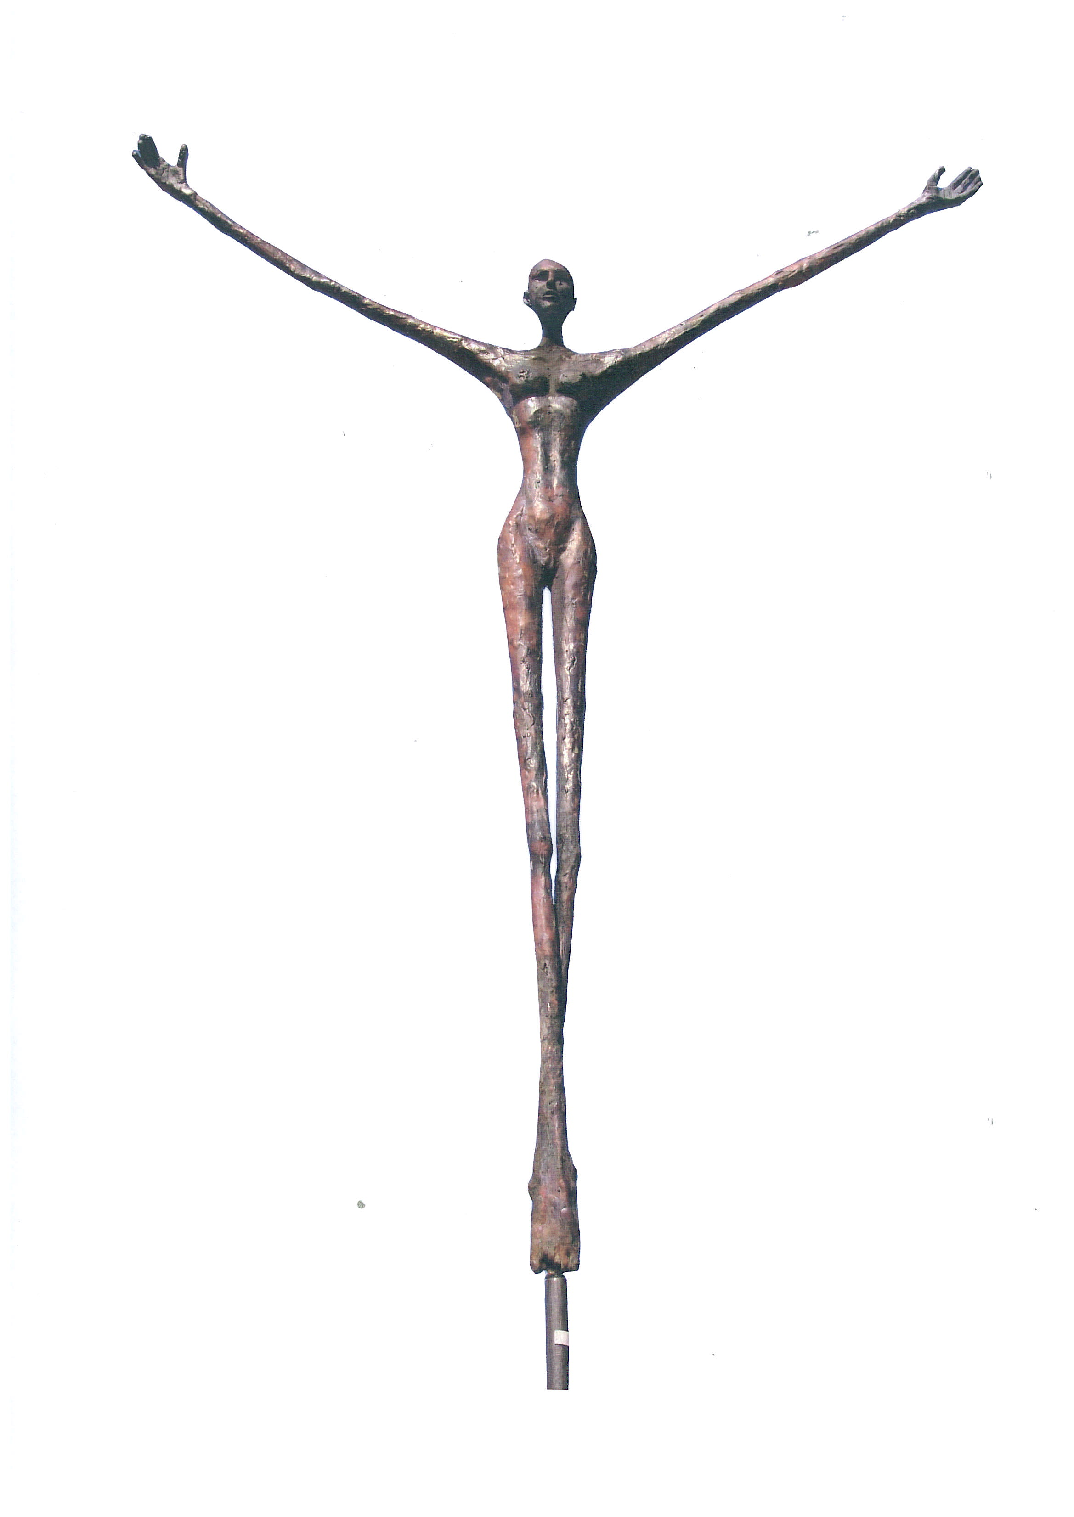
Jens Galschiot’s sculptures

displayed in Athens 2006
Survival of the Fattest: A huge fat woman from the West sitting on the shoulders of a starved African man. The 3.5 metre high copper sculpture epitomises the imbalanced distribution of the world’s resources, preserved by a biased and unjust world trade.
Hunger March: Twenty copper sculptures of starved children (170 cm). The March will appear as a mobile manifestation in many demos during the ESF in Athens 2006.
Balancing Act: a series of sculptures to mark the UN Decade of Education for Sustainable Development - manlike figures performing an apparently impossible balancing act on the top of a 5-20 metre tall pole of carbon fibres. The sculptures will be displayed throughout the world. They have already been put up in India, Norway, Sweden and Denmark. If you would like to contribute to this campaign, you can read more at
www.balancingact.dk
or contact
Lars Myrthu-Nielsen: Tel. 0045 6224 4324, eco-net@eco-net.dk

Jens Galschiot, Denmark, born 1954, sculptor. He stakes his art to defend the ethical values of our society, regardless of political, religious or economic interests. His sculptures suddenly appear in public areas and start the performance. Best known are My Inner Beast (European cities in 1993) and the Pillar of Shame (Hong Kong, Mexico and Brazil).
The projects are financed through the sale of Galschiot’s bronze sculptures to art collectors all over the world. He has a huge industrial area in Odense, Denmark with a bronze foundry, gallery and workshop. Photos of all Jens Galschiot’s sculptures: http://sculptures.aidoh.dk
Jens Galschiot - Banevaenget 22 - DK-5270 Odense N, Denmark
Phone +45 6618 4058 - Fax +45 6618 4158
E-mail aidoh@aidoh.dk - Internet: www.aidoh.dk

