Events of 2005
carried out by Jens Galschiot
and his workshop in Odense, Denmark
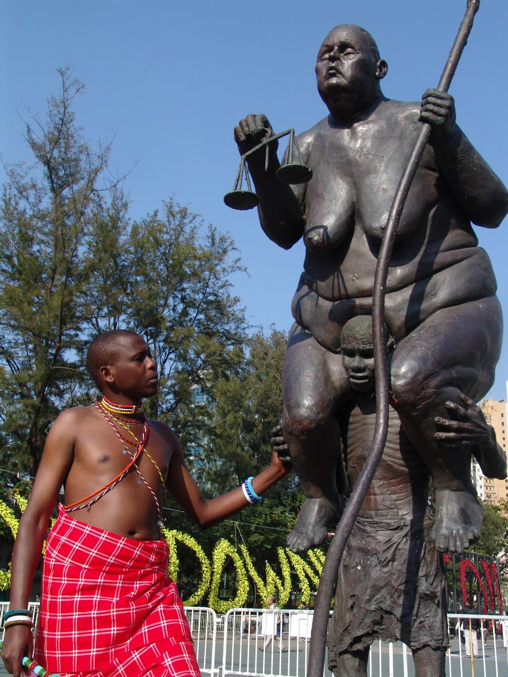
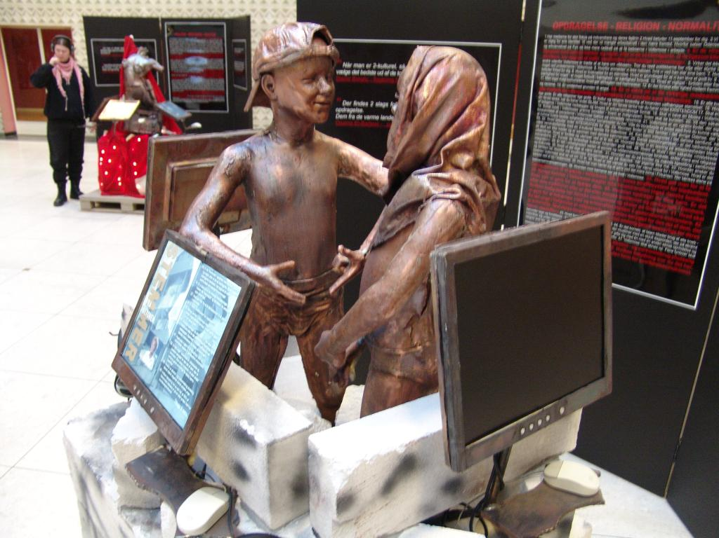
January: Voices from the Ghetto
A big installation consisting of 5 sculpture constructions, in each of which 3 computers with monitors are integrated. The interactive video project includes interviews with 25 inhabitants of an immigrant ghetto in Odense. The project is carried out in co-operation with producer Niller Madsen from the TV station Rundfunk La Rouge (Odense ser Rødt). The installation is now touring through Denmark. It can be reserved, see
http://www.aidoh.dk/?categoryID=81

January: Balancing Act
Copper sculptures representing human figures performing an apparently impossible balancing act on the top of a very tall pole of carbon fibres. They will function as a logo and eye catcher for many events throughout the UN Decade for Education for Sustainable Development (2005-2014). The project was launched during a UN conference in India by our co-operator Lars Myrthu-Nielsen from the Danish Eco-network, see
http://www.aidoh.dk/?categoryID=66

April: Hans Christian Andersen’s Hotel, Odense
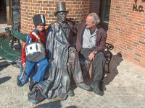
One of the biggest ornamentations ever made by Galschiot. It consists of 4 copper pillars 4 metres high sustaining the entrance section of the hotel. The pillars depict intertwined figures from Andersen’s fairy-tales. On a circular bench the poet is sitting wrapped in a cloak waiting for his cap.
The sculpture quickly became a tourist attraction. Hundreds of photos are taken every day of tourists sitting with the storyteller on the bench, see (Danish only)
http://www.aidoh.dk/?categoryID=151

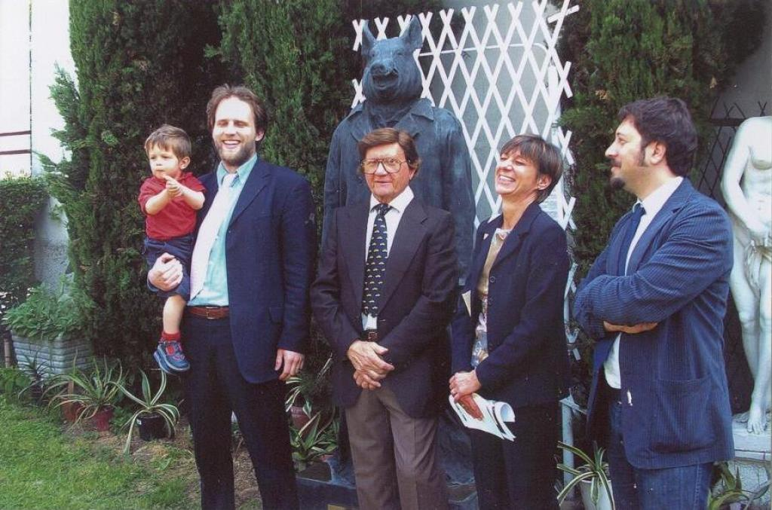
May: Milan’s Inner Beast Reinaugurated
The sculpture had been confined in a depot since 1994. After intensive searching and negotiations about release, the Beast was eventually ransomed by the Esperanto Association. In their sculpture park in Cormano, a town near Milan, the Beast was reinaugurated by the Mayor, Mr Roberto Cornelli. The Milan City Hall were conspicuous by their absence, still showing no understanding of the symbolism of My Inner Beast, see
http://www.aidoh.dk/?categoryID=129

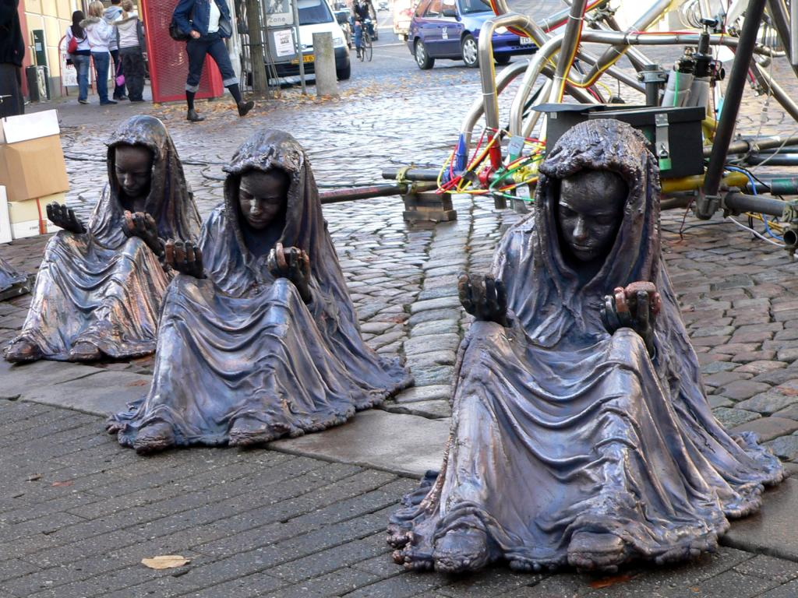
November: The Little Match Girl
Eleven copper sculptures of 10 year old girls in natural size, inspired by the tale of Hans Christian Andersen. The girls hold a bundle of matches in one hand – a mobile phone in the other. The sculptures made a tour through Denmark in connection with the municipal elections to highlight children’s living conditions in 2005.
The project was carried out in co-operation with the Educationists’ Association, BUPL.

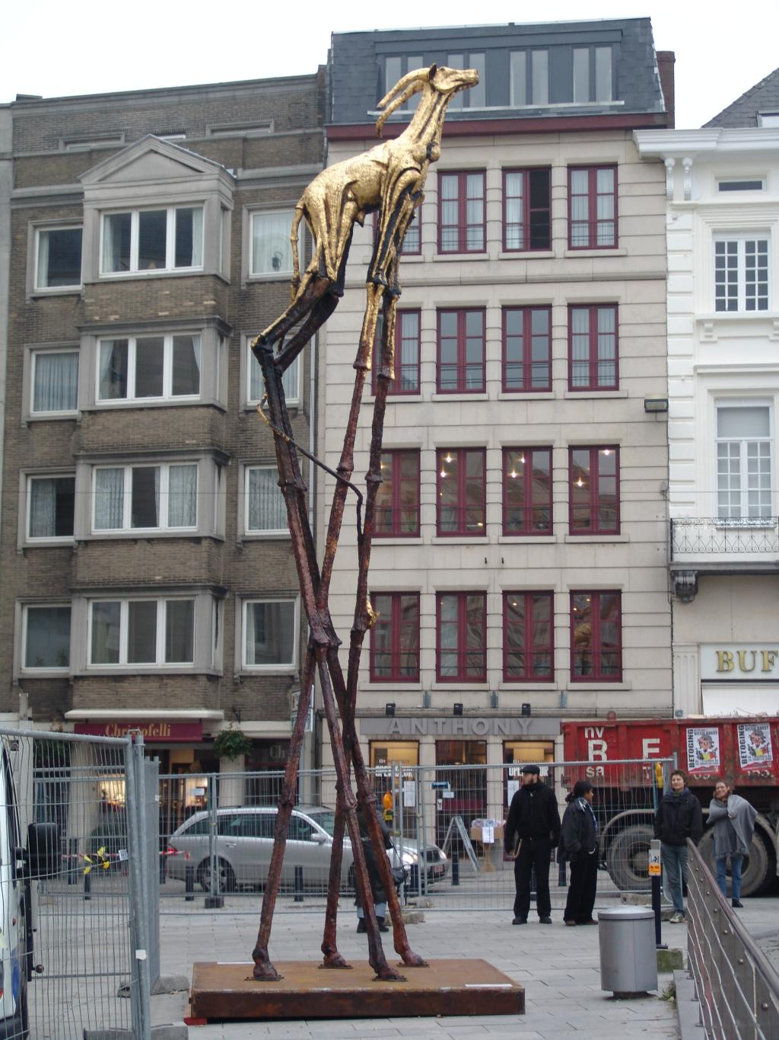

November: Golden Calf in Belgium
In the Belgian city Ghent an eight metre high biblical Golden Calf coated with 24-carat gold foil took the lead in a procession of artists, the Clown Army, samba dancers and citizens. The aim was to denounce the unethical investments of the banks.
Belgian campaigner Mathias Bienstman said: One can see the Golden Calf as a symbol of the idolatry of return and profit. The sculpture will call the banks to account. Why our savings go to weapons, dictators, sweatshops and other unethical investments? - see
http://www.aidoh.dk/?categoryID=136
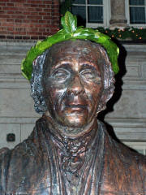
December: Hans Christian Andersen Laureated
The year 2005 – 200th anniversary of the famous storyteller was marked by an abundance of cultural events all over the country. On 6 December, the official closure of the Andersen year, Galschiot’s 3 metre high copper sculpture of the poet was displayed at the main entrance of the Town Hall of Odense. The Mayor, Mr Anker Boye, laureated the sculpture as a remembrance of the original act in 1867 as Andersen was honoured as honorary citizen.
The sculpture is intended to be integrated into The Storyteller’s Fountain that Galschiot will create to be set up in a noiseless square in Odense, provided that the funding be achieved, see
http://www.aidoh.dk/art_and_events/hca/GB-Storyteller.htm

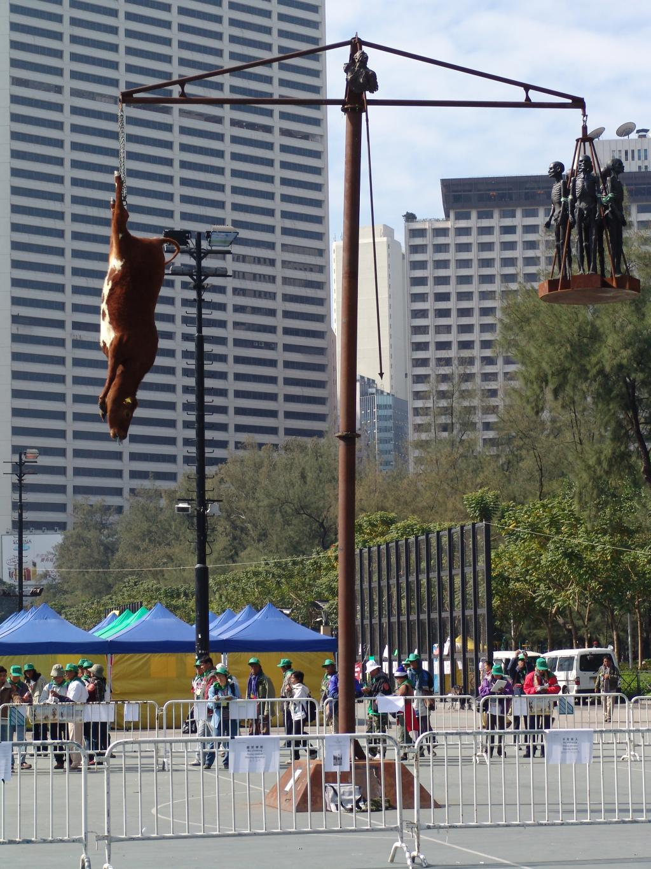

December: WTO Conference in Hong Kong
Three sculpture groups had come to Hong Kong to pinpoint the inequitable world trade. Survival of the Fattest and The Hunger March had already been displayed on various occasions. Mad Cow Disease had just been displayed once before. The sculpture represents a pair of scales, 8 metres high. On one arm hangs a dead cow by its legs, on the other a number of Africans (in copper). The aim of the sculpture is to depict the rich world’s absurd ‘madness of subsidies’.
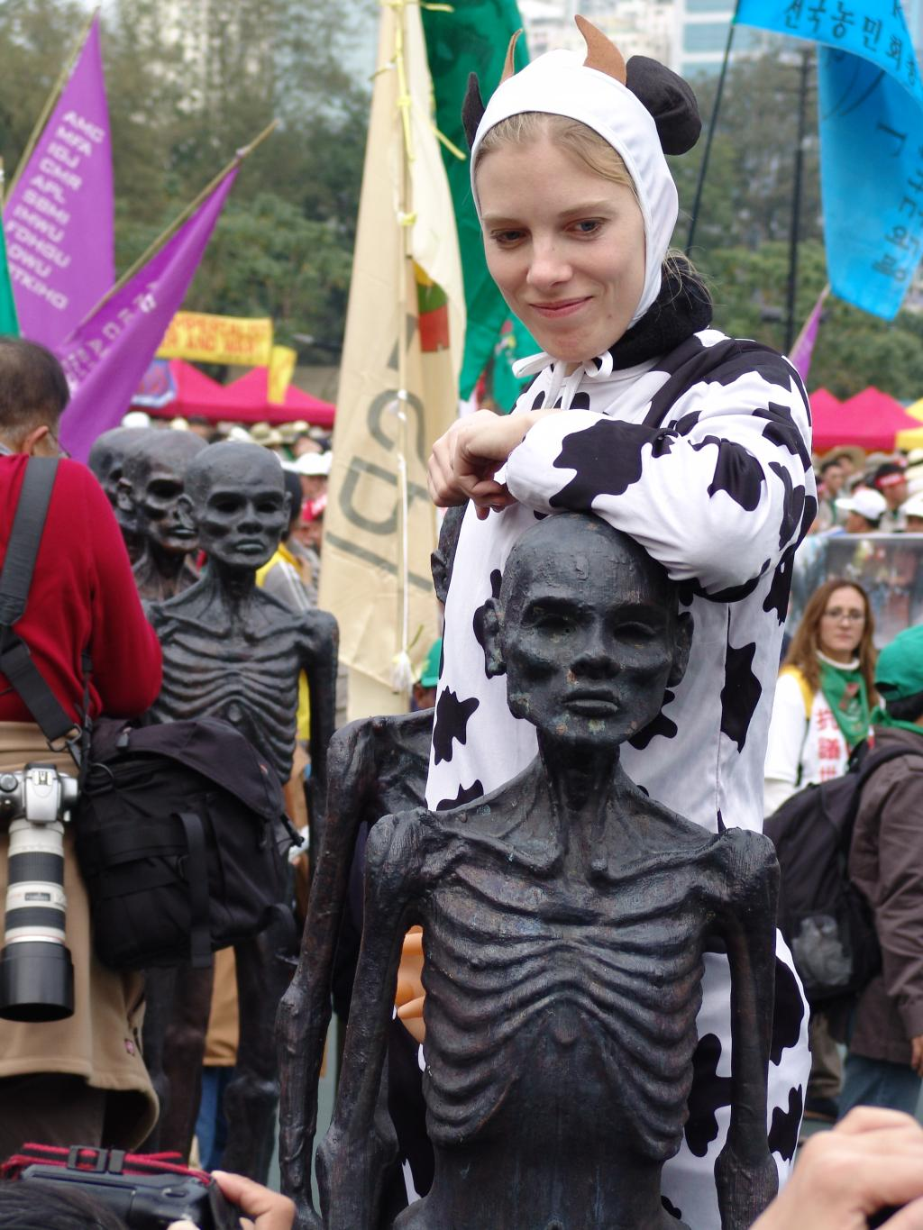

The sculptures were met with an endless series of obstruction from the manager of Victoria Park. After days of tug-of-war Jens Galschiot succeeded to set up his sculptures in the park. Perhaps the sculptor’s threat to file a lawsuit against the authorities through the renowned Hong Kong lawyer Albert Ho was decisive.
The sculptural outcry has achieved unprecedented coverage in the media, see
http://www.aidoh.dk/WTO

Jens Galschiot, Banevaenget 22, DK-5270 Odense N, Tel.: +45 6618 4058, Fax +45 6618 4158, aidoh@aidoh.dk, www.aidoh.dk

